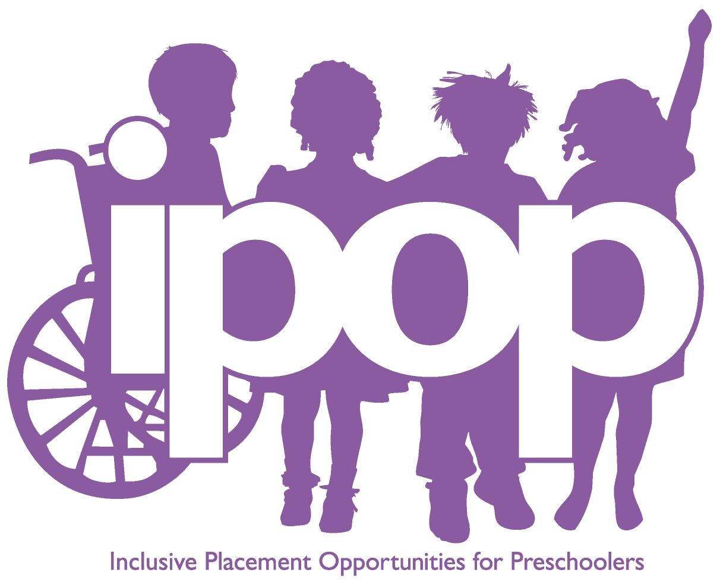Activity: Legal Rationale for Inclusion in
Early Childhood Programs

Directions: Using the “Dear Colleague Letter” and the “Virginia Guidelines for Early Childhood Inclusion,” answer the following questions below.

1. What should all young children with disabilities have, according to the DEC/ NAEYC joint position, in order to acquire inclusive high-quality early childhood programs where they are provided with individualized and appropriate supports to enable them to meet high expectations?

2. What was the name of the policy statement issued in September, 2015 by the US. Dept of Health and Human Service and US Dept of Education?

3. What does the acronym LRE stand for?

4. A preschool child with a disability who is eligible to receive special education and related services and his or her parents are entitled to all the rights and protections guaranteed under what part of the law, and its implementing regulations in 34 CFR Part 300?

5. What is one of those rights?

6. What is considered a “regular class”?

7. What is FAPE?

8. What are four methods that a local school division or LEA can explore in order to ensure that they have met requirements for their preschoolers with disabilities?

9. What percentage of children, according to the US Department of Education, is required in order to be considered a Regular Early Childhood Program?
According to how data is collected, children with IEPs who are attending these regular early childhood programs, must be receiving the majority of their services in this environment.

10. What are some examples of those environments?

11.What does ADA stand for?
It creates opportunities for preschoolers with disabilities to attend the same community-based early childhood programs as their peers who are typically developing.

12. What are children with disabilities entitled to, when referring to accessibility to programs?
Programs must make reasonable accommodations to enable children with disabilities to participate in and benefit from the services offered (USDHHS & USDOE, 2015)

13. What is the Head Start Act?
Since 1972, Head Start has required, that at least 10% of it’s enrollment consist of children with disabilities who are eligible for special education services and related services under IDEA.

References

US Department of Education, Office of Special Education and Rehabilitative Services. (201, January 9). Dear Colleague Letter on Least Restrictive Environments in Preschool. Available at https://www2.ed.gov/policy/speced/guid/idea/memosdcltrs/preschool-lre-dcl-1-10-17.pdf

Virginia Department of Education. (2018). Virginia guidelines for early childhood inclusion. Richmond, VA: Author.

